**Page Properties:  Reusable Properties**

**Types of Page Properties:**

**1- Single Page: It will hold Multiple Properties but we can assign one value at a time.**

**2- Page List: It will hold Multiple Properties but we can assign Multiple  values at a time, List Index will be Integer**

**3- Page Group: It will hold Multiple Properties but we can assign Multiple  values at a time, Group Index will be Alphabetic/Alpha Numeric**

**Definition Single Page/Page List /Page Group Property:**

**Page will hold Multiple Properties/ Page is collection of Properties**

**Page acts as reference to Data class properties. Page must always refer to some Data Class.**

**Rule Instance for Page Properties: Rule-Obj-Property.  ( PR4_Rule_Property)**

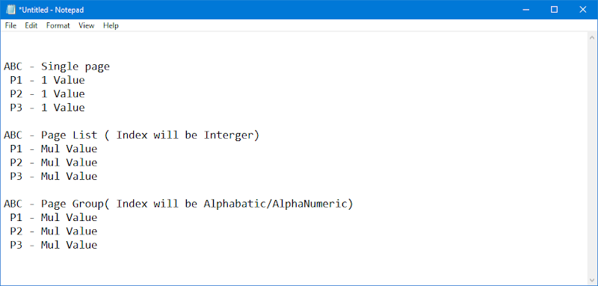

**Working with Single Page Property:  Reusable Properties**

**Page Property: Single Page**

**Single Page:/PageList/PageGroup:  hold multiple properties**

**Disadvantage of Single Value Properties when created in work Layer:**

**- Properties can be used in Same Class**

**- Max we can use in one UI Design**

**- If We use Property in Multiple Designs the Same Value will copy in other Designs.**

**Single Value Properties:  Clipboard structure will be in below format:**

**pyWorkPage.FName**

**pyWorkPage.LName**

**pyWorkPage.Age**

**Example:**

**Data Class: Properties( FName, LName, Age ) - Single Value Properties**

**CustPage ( Data Class)      ManagerPage( Data Class)       HRPage ( Data Class)**

**FName                                 FName                                         FName**

**LName                                 LName                                         LName**

**Age                                       Age                                              Age**

**Page Properties: Clipboard structure will be in below format:**

**pyWorkPage.CustPage.FName: ABC**

**pyWorkPage.MangrPage.FName: BVC**

**pyWorkPage.HRPage.FName: ABF**

**How to Create & Use Page Properties:**

**Step1: Add Data Class for Reusable Properties ( Division Level data Layer)**

**Step2: Add Properties under Data Class ( Single Value)**

**Step3: Add Single Page Properties in Work Class group (Referring to Data Class)**

**Step4: Use Single Page Properties in Section**

**Working with Single Page Properties**

**Req: Create a set of reusable properties to Collect Vehicle Details & Claims Details**

**Personal Vehicle Page**

**Create a Data Class for Reusable Properties:**

**Add Reusable properties under Division Level data Class/Data Layer/Data Class Group**

**Add a New Data Class: Vehicle**

**Add data class from data type Explorer:**

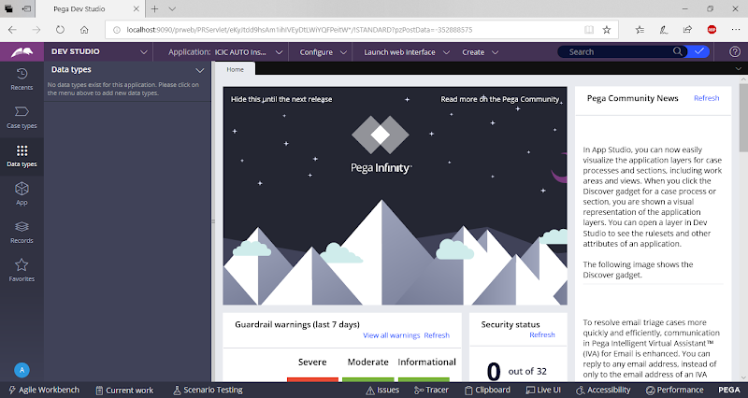

**From Dropdown Select Add Data Type**

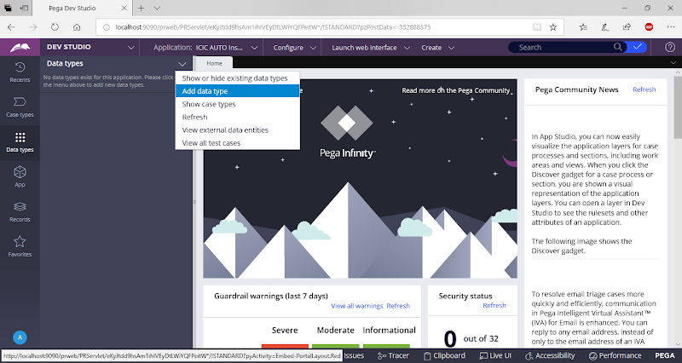

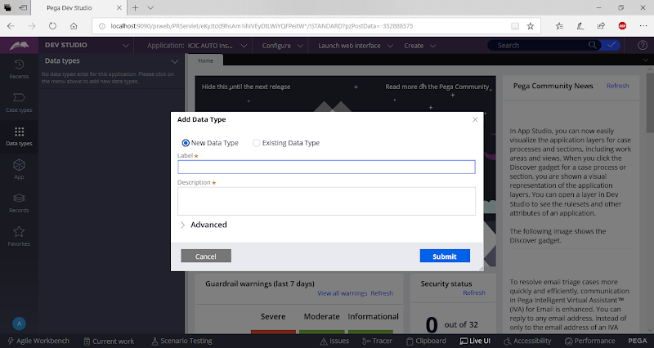

**Add Data Class Name**

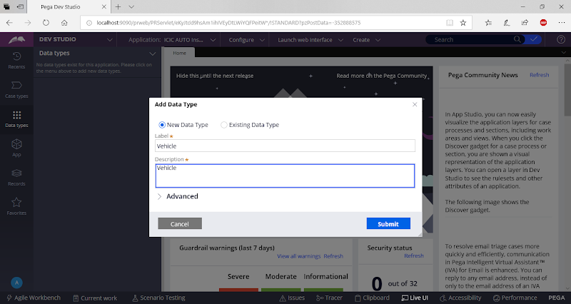

**Click on Submit**

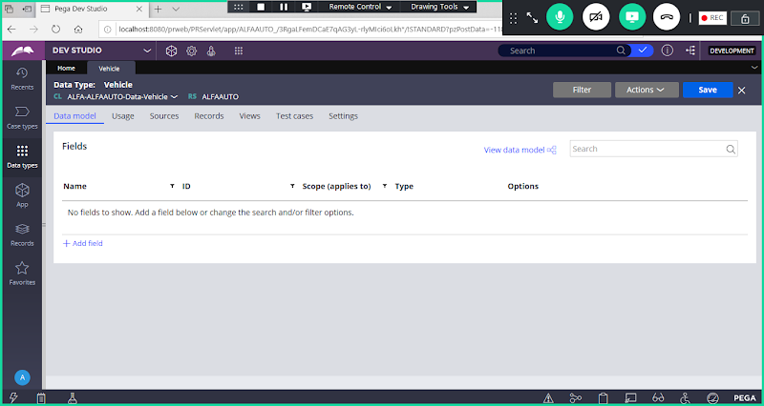

**Add Properties under Vehicle Data Class using Property Wizard:**

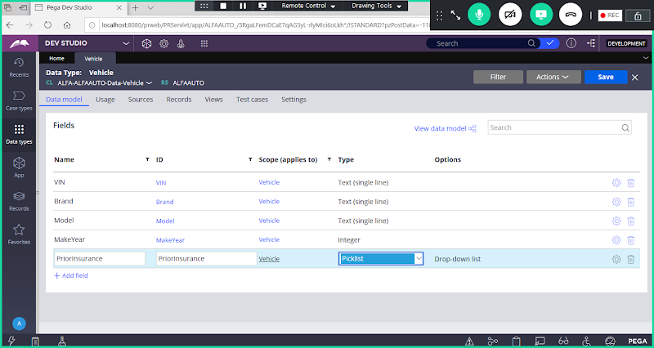

**Add Values for priorinsurance**

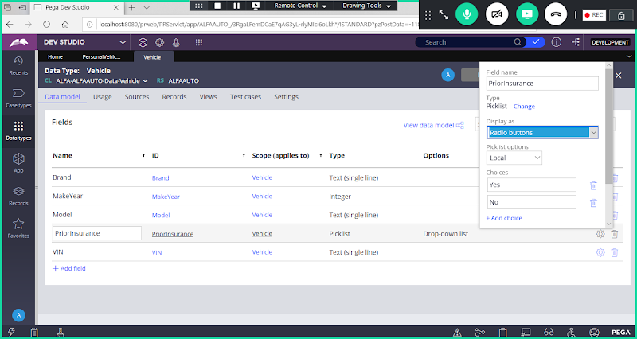

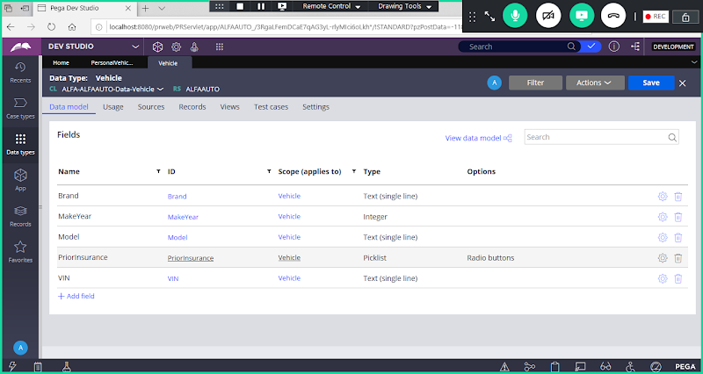

**Now Go to App Explorer:**

**Under Work Class Group Add Page Property: PersonalVehiclePage**

**Create a Page Property Under Work Class Referring to Vehicle Data Class:**

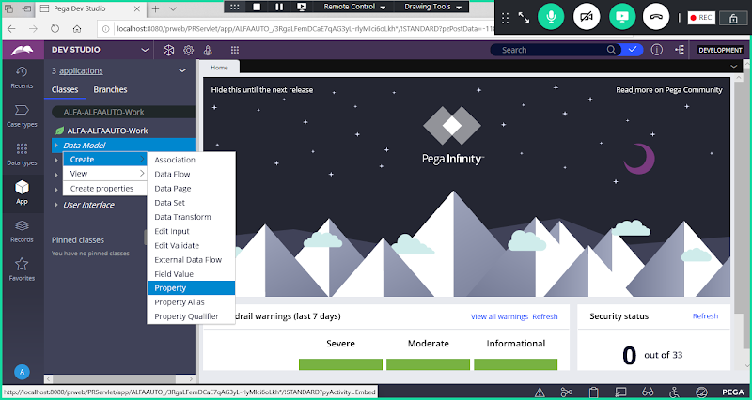

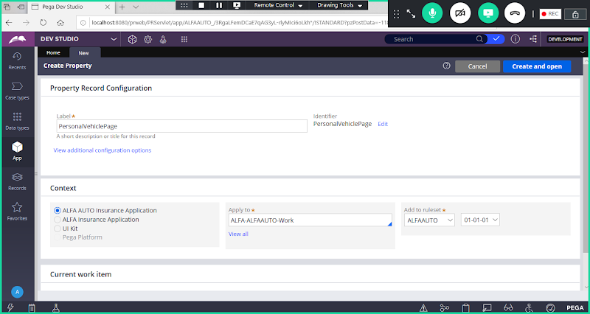

**Open**

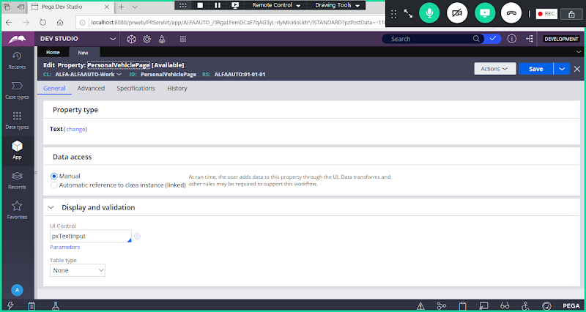

**Click on Change.   Change Type: Single Page**

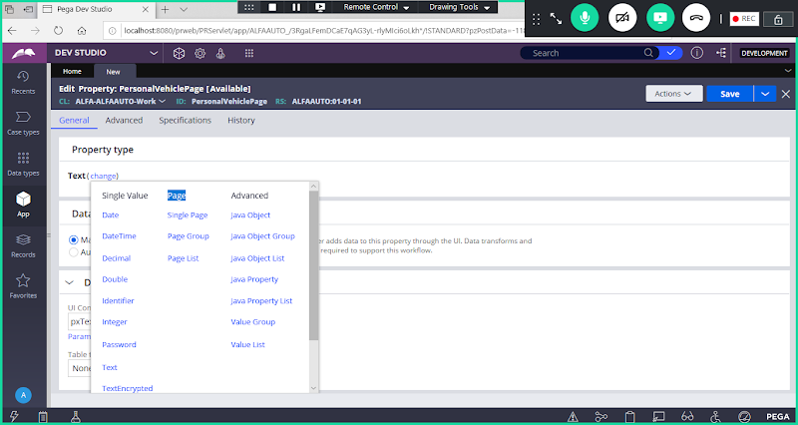

**Select Single Page**

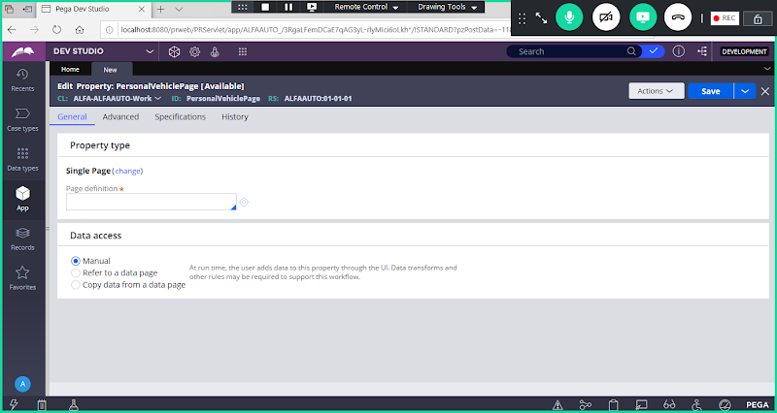

**Give Vehicle Data Class Name**

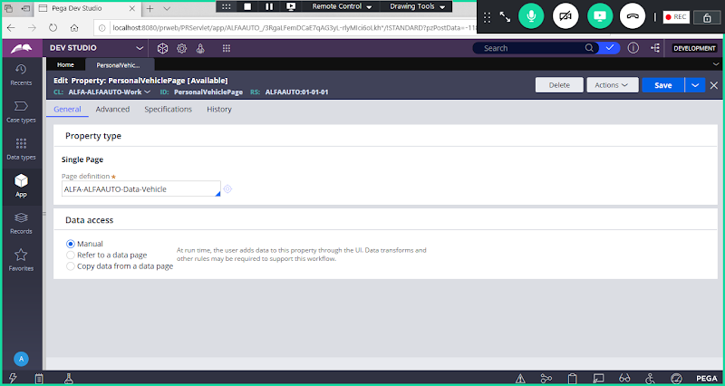

**Save Property**

**Refersh Work Class:**

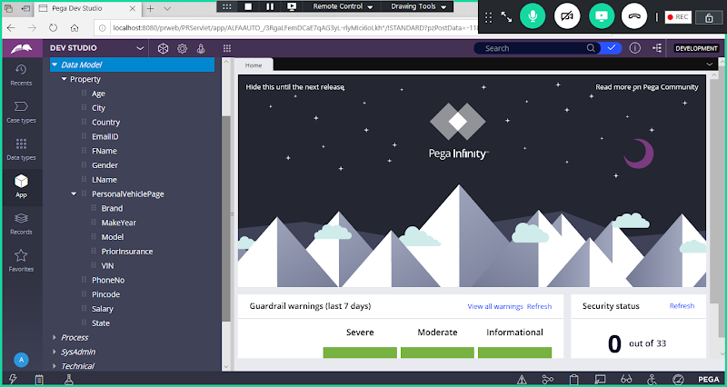

**-====**

**Req: Create Data Class , Properties & Page Property to Collect Claims details:**

**Create a New Data Class: Claims**

**Add data Class from Data Type Explorer:**

**Click on Add Data Type**

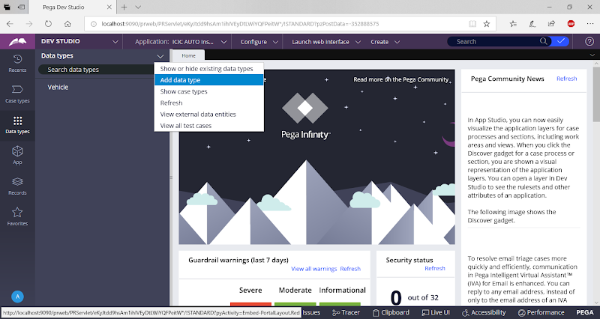

**Add Data Type Name: Claims**

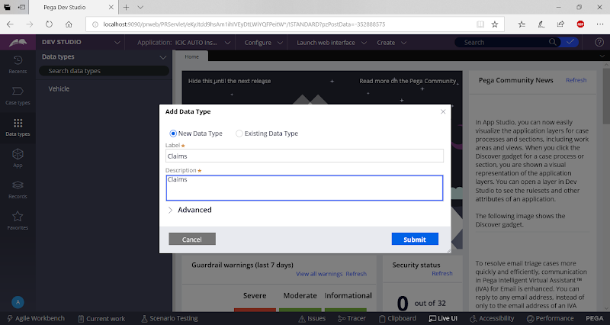

**Click on Submit**

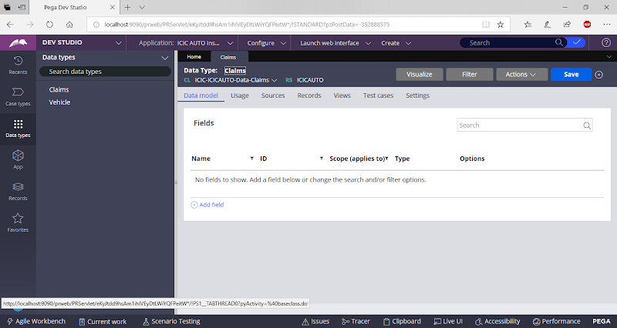

**Add Fields**

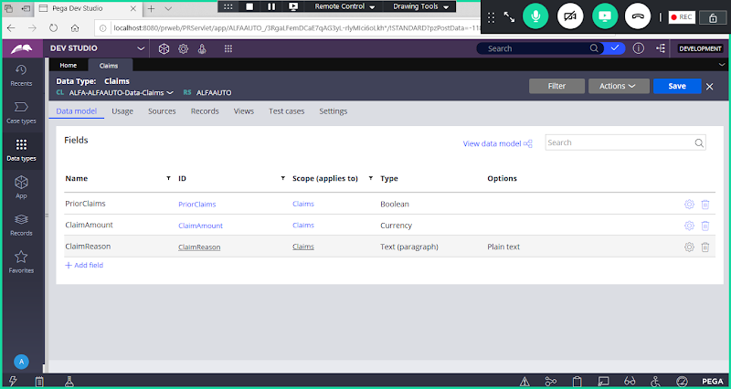

**Now Go to Work Class group:**

**Add ClaimsPage Property under Work Class group referring to Claims Data Class:**

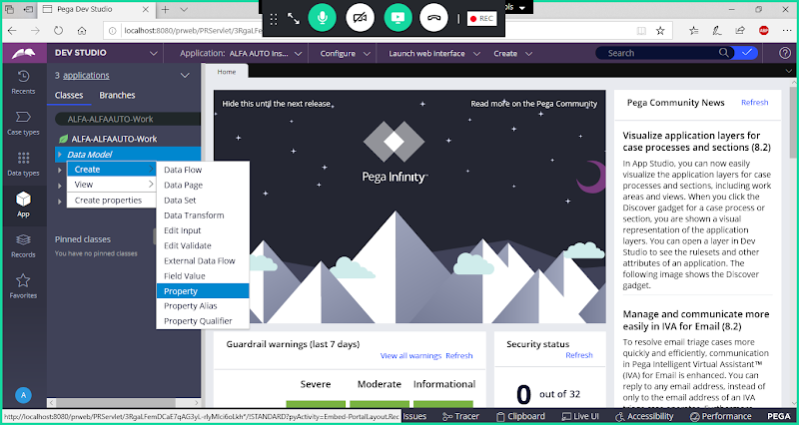

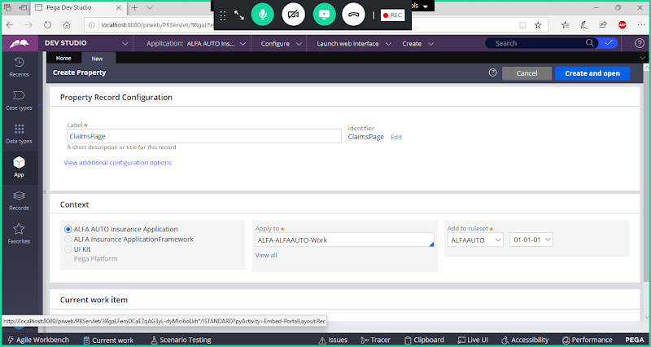

**Open**

**Select Type: Single Page & Add Claims Data Class**

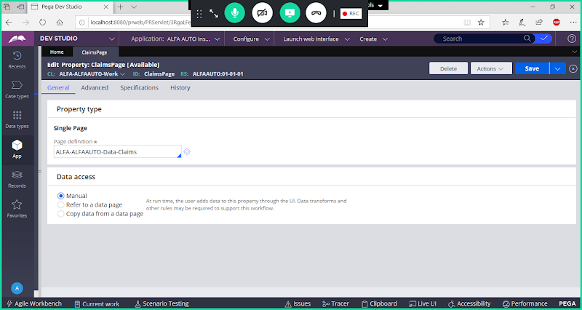

**Save Property**

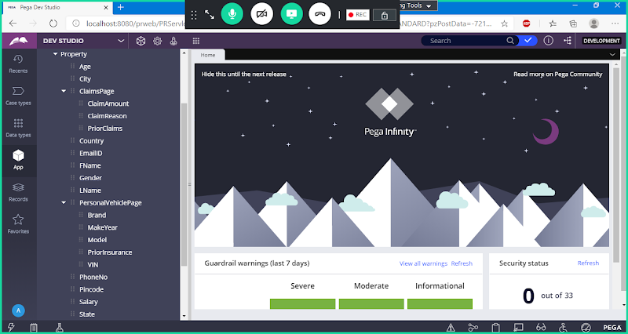

======

**Using Single Page Properties in Section:**

**Req:**

**Create a New section & Add Personal Vehicle Page & Claims Page properties in same section but in different layouts:**

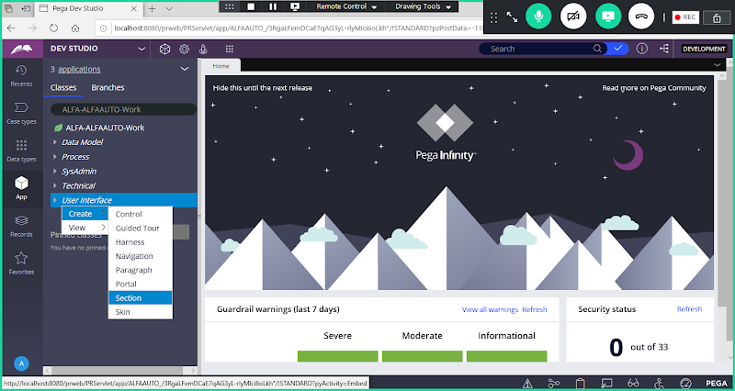

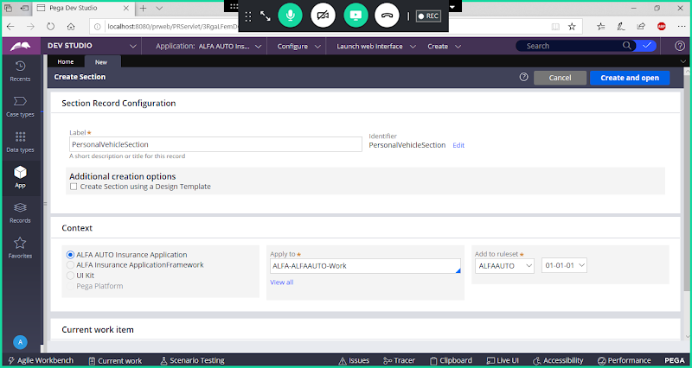

**Open**

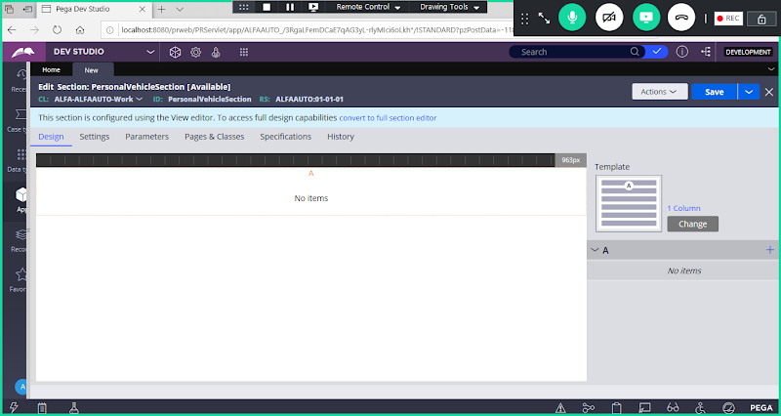

**Now Covert to Full Section Editor**

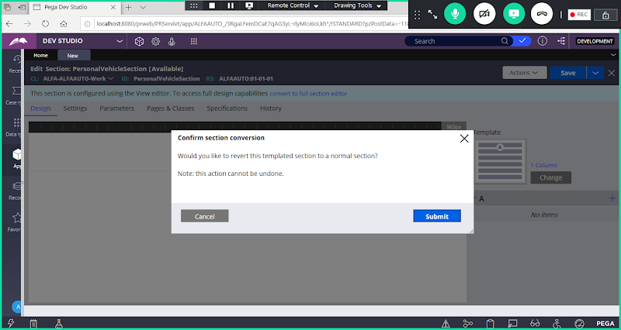

**Click on Submit**

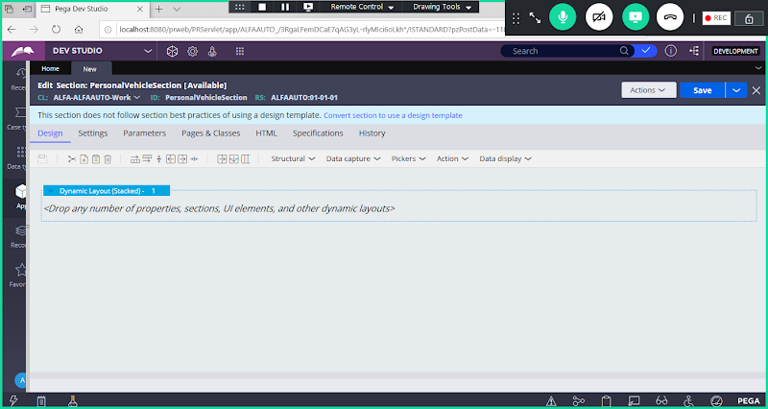

**Set Layout Format & Add Title & Header for the Layouts**

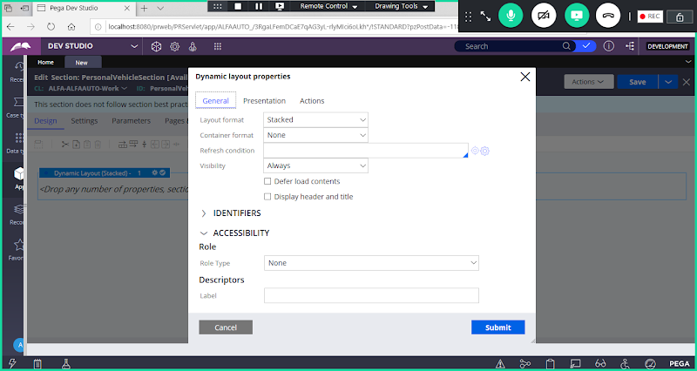

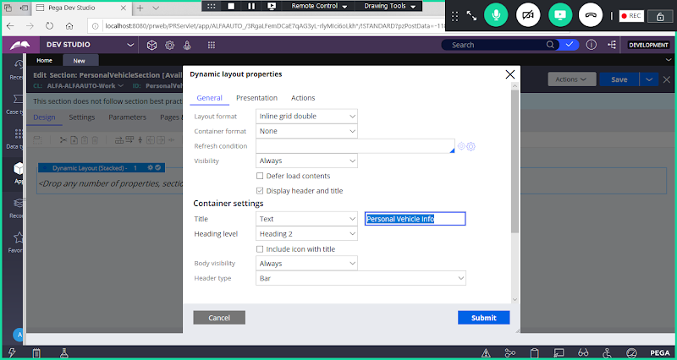

**Click on Submit**

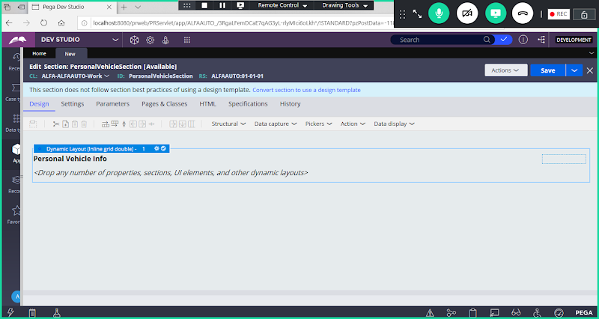

**Add Sub Layout ( In Layout1 -> Add dynamic Layout 1.1)**

**Add Sub Layout & Set Format for 1.1**

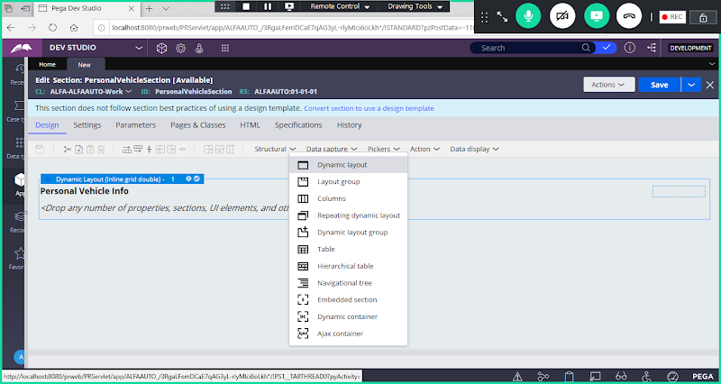

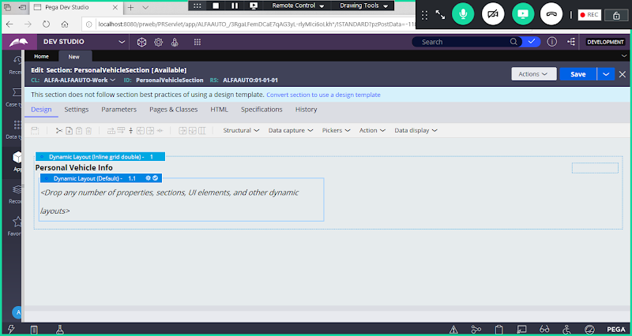

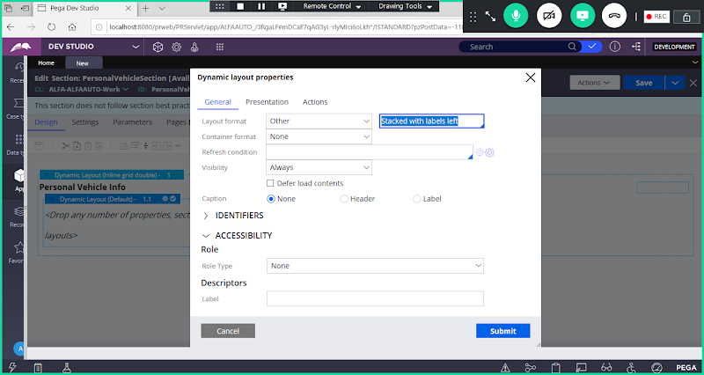

**Click on Submit**

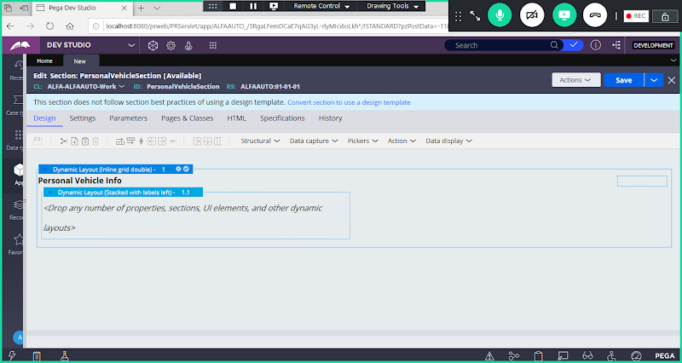

**Now Add Layout2 to Collect Claims Details:**

**Right Click on Layout1 -> Select Copy**

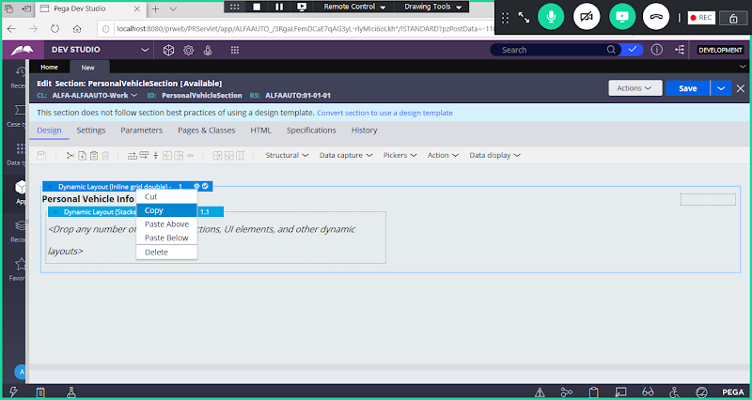

**Again Right Click -> select Paste Below**

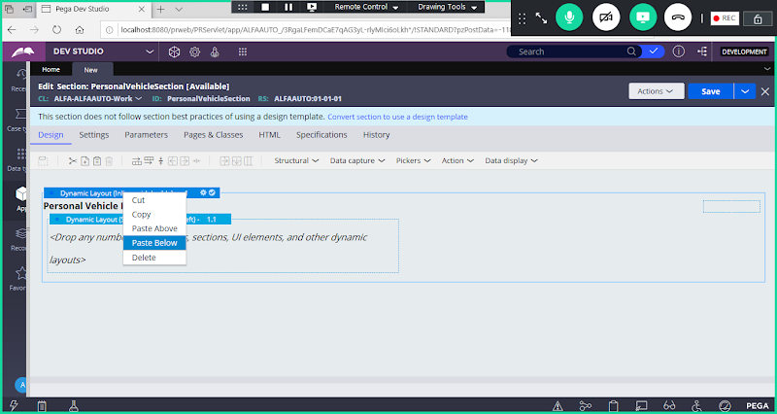

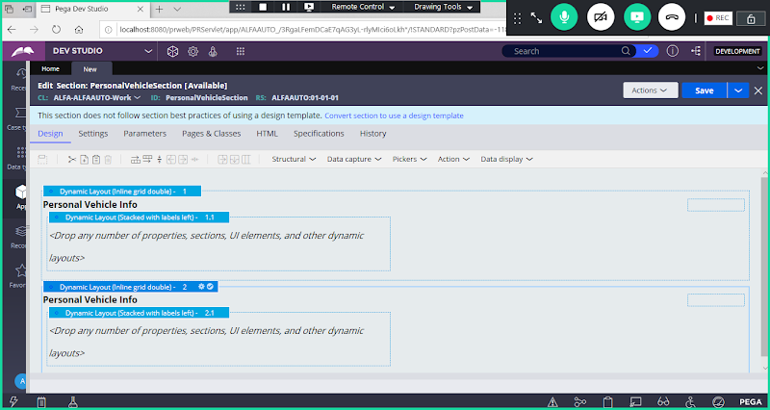

**Now Change Title for Layout 2**

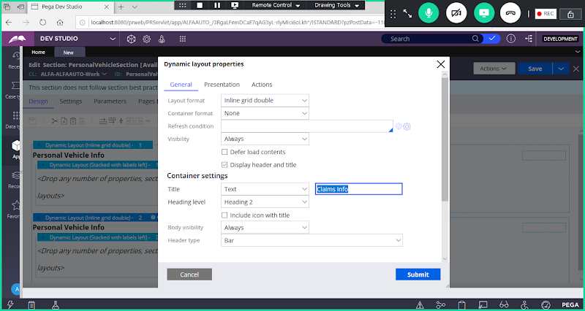

**Submit**

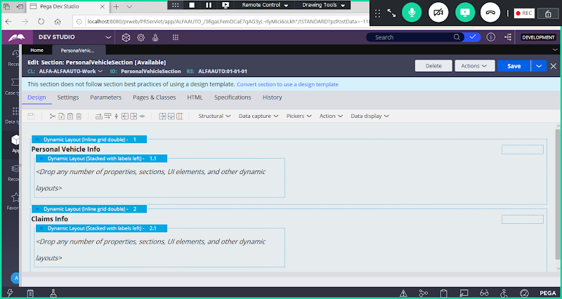

**====**

**To Map Properties first Add UI Elements/Controls:**

**From basic drop down add controls: ( 4 text input & 1 Radio button) , Drop inside Layout 1.1**

**Property Name - Type - Control**

**VIN -                       Text     - TextInput ( Data Capture)**

**Brand-                   Text      - TextInput (Data Capture)**

**Model-                 Text       - TextInput( Data Capture)**

**MakeYear-          Integer-   Integer ( Data Capture)**

**PriorInsurance-  Text -      RadioButton (Pickers)**

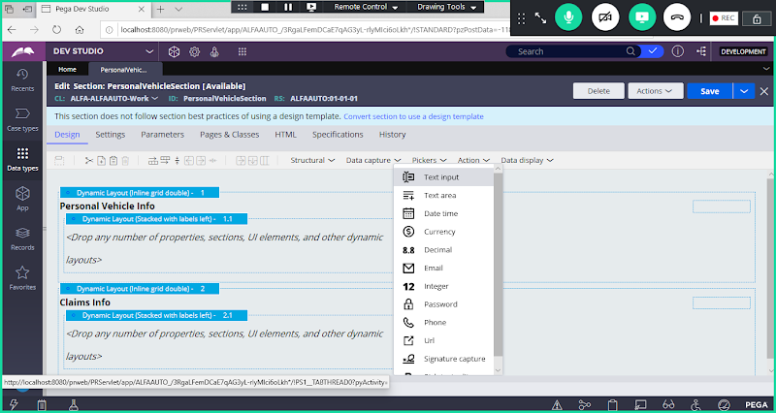

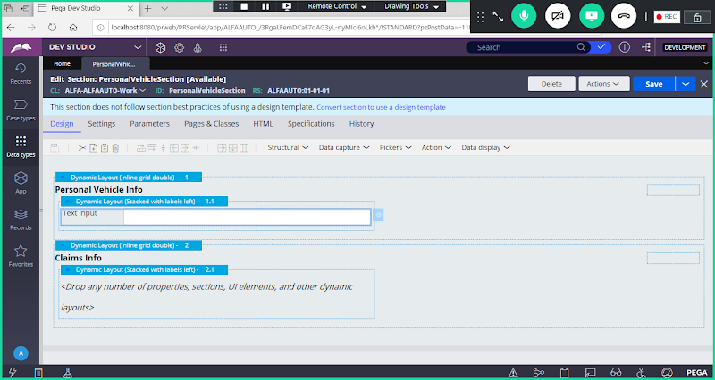

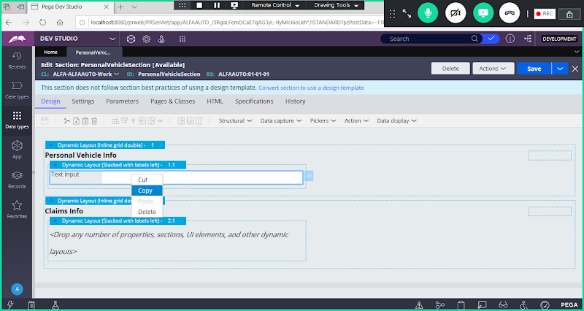

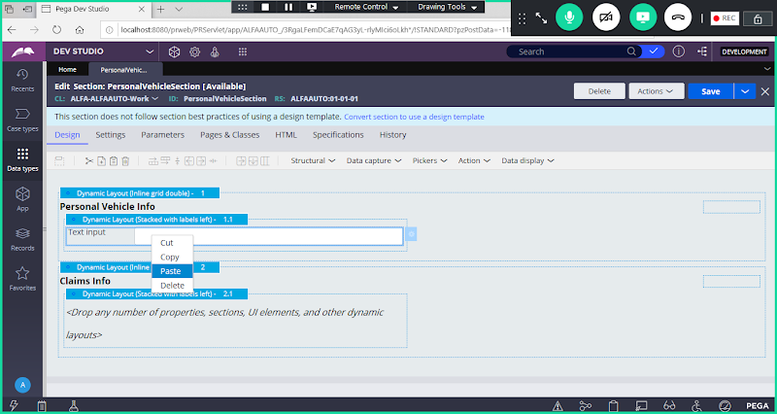

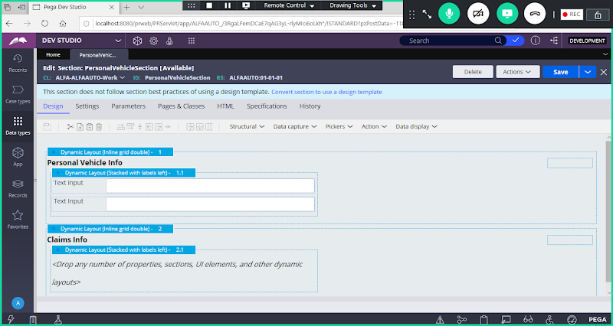

**Add Integer Control**

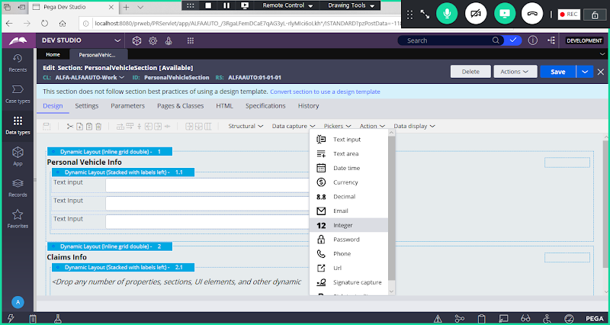

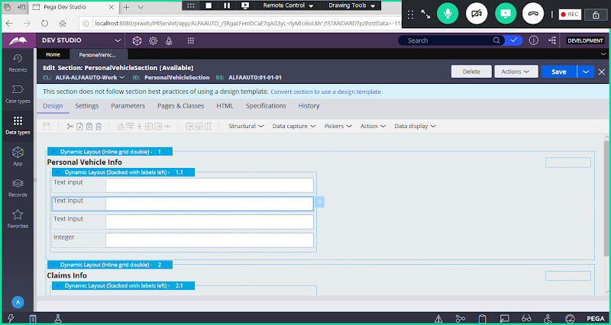

**Add Radio Buttons from Pickers**

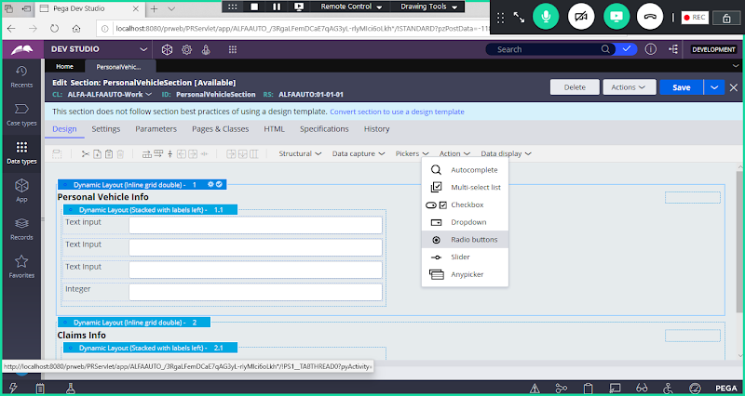

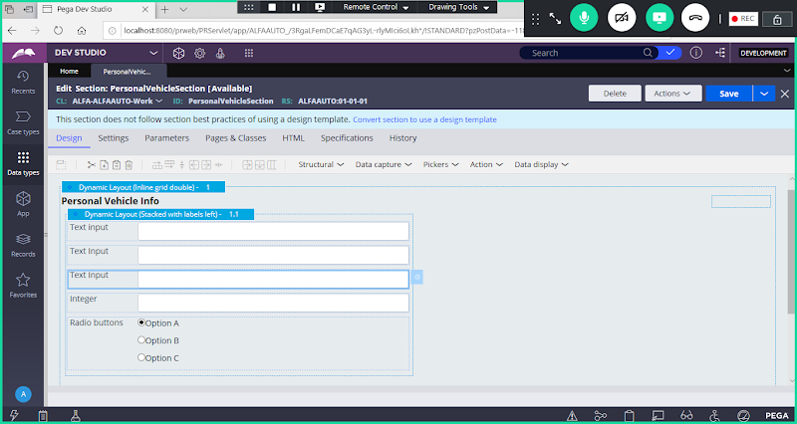

**Similarly add Controls in Claims Layout:( Check box, Text input, Text area)**

**Prior Claims:   Boolean - Check box  ( Pickers)**

**Claim Amount: Currency - Currency( Data Capture)**

**Claim Reason:  Text Paragraph - Text area ( Data Capture)**

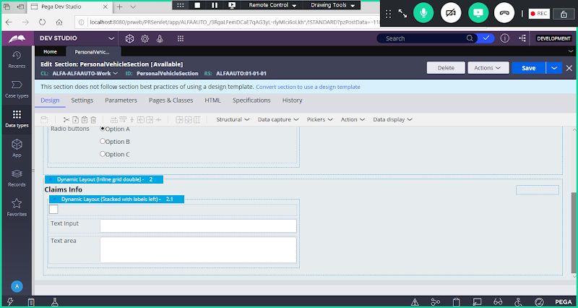

**Now Map Properties from Personal Vehicle Layout:**

**Double Click on Control:**

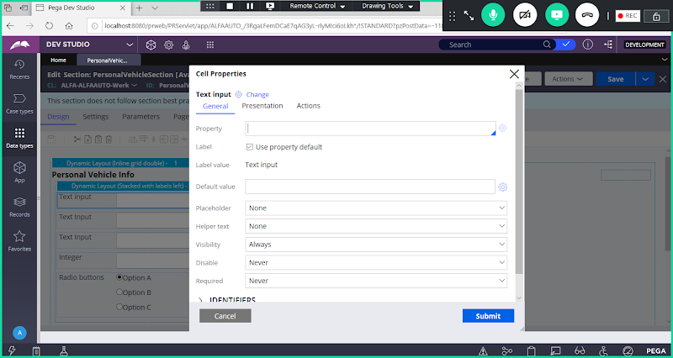

**Select Property from dropdown:**

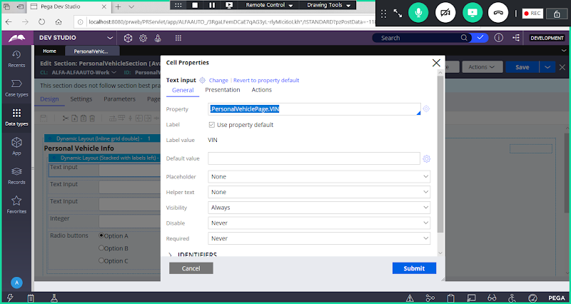

**Click on Submit**

**----**

**PersonalVehiclePage.VIN**

**PersonalVehiclePage.Brand**

**PersonalVehiclePage.Model**

**PersonalVehiclePage.MakeYear**

**PersonalVehiclePage.PriorInsurance**

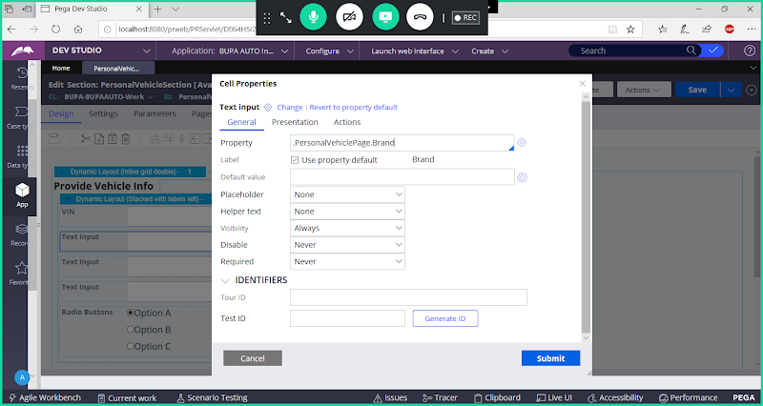

**Submit & Similarly map remaining properties in Vehicle Form**

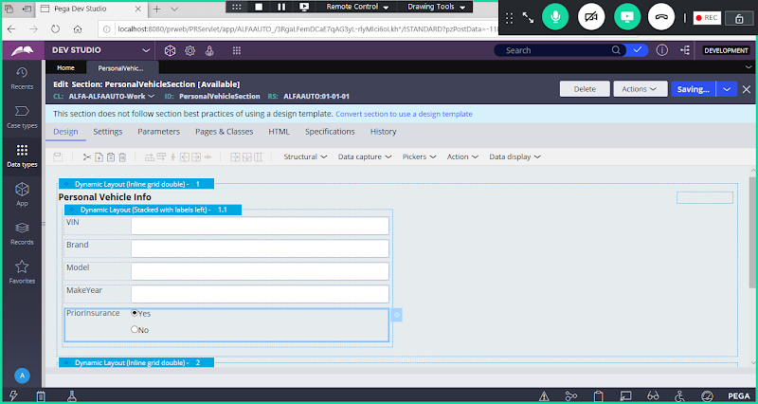

**Map Claims Layout Properties:**

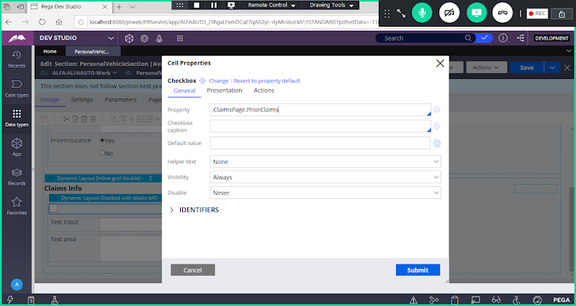

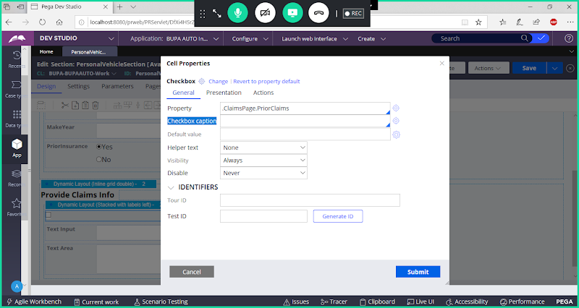

**Add Check box caption:**

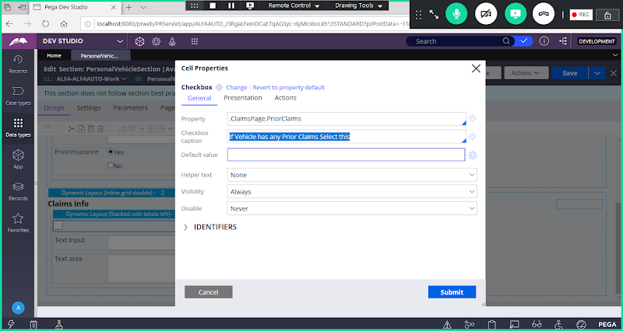

**Submit**

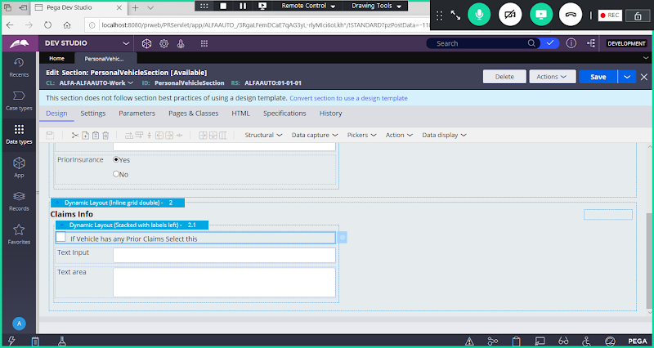

**Map Remaining Properties:**

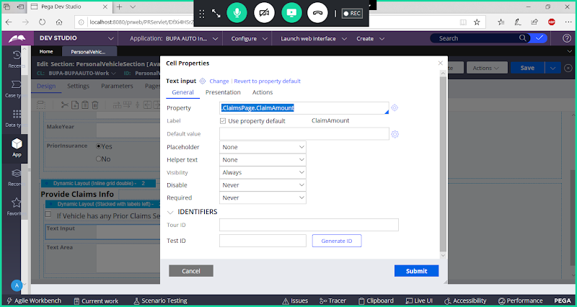

**Submit**

**Add Claims Reason:**

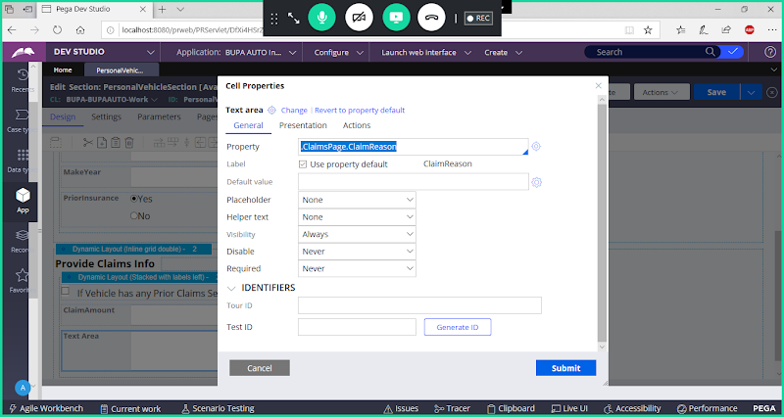

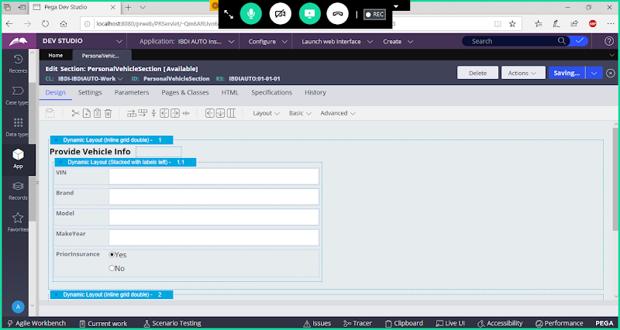

**Save Section**